Owen Knight

TL 4

Error 404

4/15/24

ItemSlot Prefab Documentation

Introduction

In our game, there is an inventory that is used to store the various keys that the player collects. Within this inventory, there are 6 slots where items can be displayed. These slots are panel prefabw called ItemSlot.

Location/Structure

Figure 1: Location of ItemSlot Prefabs With Repect To The SampleScene (Highlighted In Gray)

Figure 2: Item Slots In Inventory (Light Blue Squares On Left Side)

The ItemSlot prefabs encompass 3 UI objects:

1. SelectedShader: A panel that is slightly larger than the slots themselves. Is there to highlight an item slot whenever the player clicks on it. When a player clicks on another nonselected item slot, it “moves” to it.
2. QuantityText: A Text Mesh Pro object that shows how many items of a specific type are in an item slot. Probably not needed for our game in the end due to its small size.
3. ItemImage: The image of the item in the item slot, given that there is one there.

Script Structure

Figure 3: The General Structure of The ItemSlot Script.

Script Functions

* Start
  + Type: Private Void
  + Arguments: N/A
  + Purpose: Reference the InventoryManager script in order to use its functions.

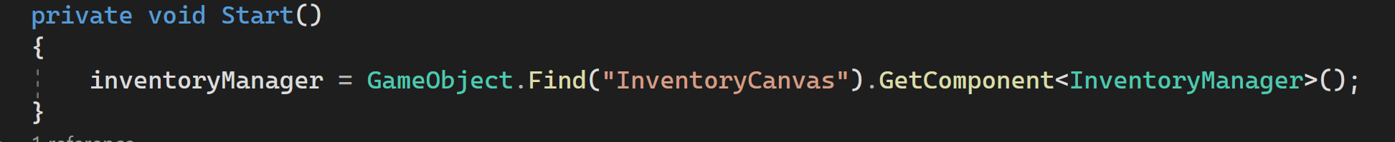

Figure 4: Start Function In ItemSlot Script

* AddItem
  + Type: Public Void
  + Arguments: string itemName, int quantity, Sprite itemSprite, string itemDescription
  + Purpose: Add info about one and an item itself to an item slot.

Figure 5: AddItem Function In itemSlot Script

* OnPointerClick
  + Type: Public Void
  + Arguments: PointerEventData eventData
  + Purpose: Calls OnLeftClick function if player left clicks on an item slot.

Figure 6: OnPointerClick Function In ItemSlot Script

* OnLeftClick
  + Type: Public Void
  + Arguments: N/A
  + Purpose: Turn on SelectedShader panel over item slot and display info about the item that the player left clicks on. Uses DeselectAllSlots function in InventoryManager script.

Figure 7: OnLeftClick Function In ItemSlot Script

Why?

Why was the ItemSlot prefab created? Well, it was mainly for reusability reasons. Would’ve taken a lot longer and a would’ve been a lot more repetitive if it was done from scratch 6 times over. Making ItemSlot a prefab allowed it to just be copied and pasted a few times.